16.5: a) Using Equation (16.7),
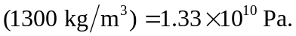
- Using Equation (16.8),
